**PORTFOLIO PROJECT**

Submitted by

## SANTHOSH S

**Reg. No: 1P23MC050**

In partial fulfilment of the requirement for the award of the Degree of

## Master of Computer Applications Bharathiar University Coimbatore.

Under the Internal Supervision of

## Mrs. K. Swathy

**Faculty**

**School of Computer Studies-MCA**



## Master of Computer Applications,

**Rathnavel Subramaniam College of Arts and Science (Autonomous),**

## Sulur, Coimbatore – 641 402

**Nov 2023**

## RATHNAVEL SUBRAMANIAM COLLEGE OF ARTS AND SCIENCE (AUTONOMOUS)

**AFFLIATED TO BHARATHIAR UNIVERSITY**

**NAAC Re-accredited & ISO 9000:2008 Certified**

**SULUR, COIMBATORE-641402.**



**Nov 2023**

**Register Number – 1P23MC050**

Certified bona fide original record of work done by **SANTHOSH S**

## Internal Supervisor Director

Submitted for the project Evaluation and Viva voce held on**………………….**

## Internal Examiner External Examiner

## CONTENT INDEX

|  |  |
| --- | --- |
| **Chapter** | **Page No.** |
| **Chapter 1**: Video Introduction   * 1. YouTube Video | 1 |
| **Chapter 2:** Website Bio Score  2.1 About me  2.2 Contact Information | 2 |
| **Chapter 3**: Pages & Navigation  3.1 Landing Page  3.1.1 Responsive Query  3.2 Project Page  3.3 Navigation bar  3.4 Skill Page  3.5 Qualification Page | 7 |
| **Chapter 4**: Style Score  4.1 Styles  4.2 Style links | 34 |
| **Chapter 5**: Website include the following Information  5.1 Project link to the GitHub  5.2 Project Description | 36 |
| **Chapter 6**: Bootstrap  6.1 Uses of Bootstrap | 40 |
| **Chapter 7**: Project README  Title description  How to run the project  Future improvement in the Project | 41 |
| **Chapter 8**: File structure  8.1 GitHub file Structure | 46 |

PORTFOLIO PROJECT

## CHAPTER 1:

## Video introduction

* 1. **Youtube video:**

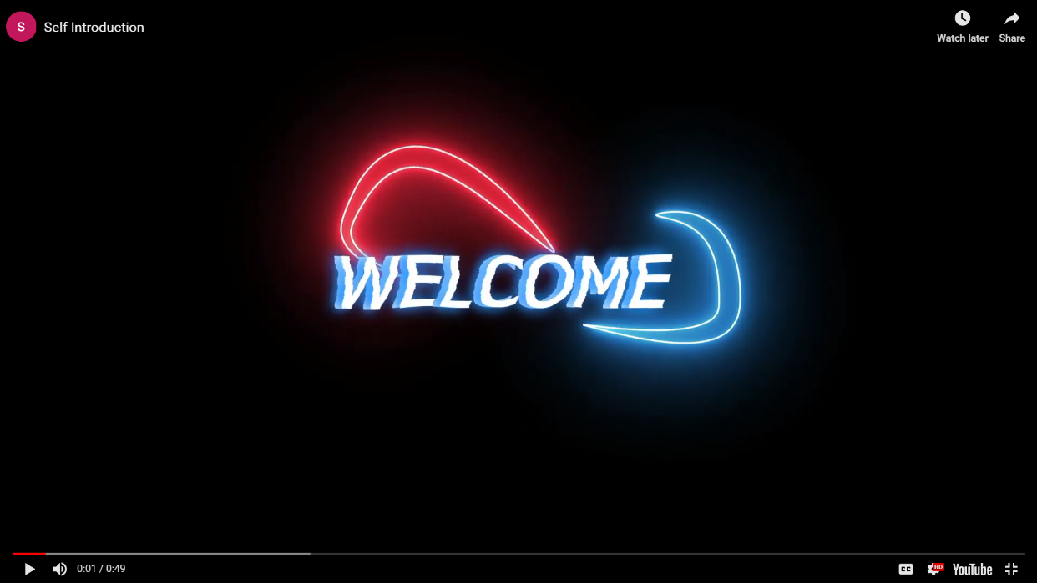

**Description:**

In this page you can the see the self-introduction of mine,by clicking the play button

you will know me more.

**YOUTUBE LINK:**

<https://youtu.be/6ibDQurRrY8?si=J4TAuO_eCA-dZ6ZO>

Source code:

|  |
| --- |
| HTML: |
| <iframe width="560" height="315" src="https://www.youtube.com/embed/6ibDQurRrY8?si=D-mWJsRXZPHMFoed" title="YouTube video player" frameborder="0"           allow="accelerometer; autoplay; clipboard-write; encrypted-media; gyroscope; picture-in-picture; web-share" allowfullscreen>          Self Intro</iframe> |

**CHAPTER 2:**

**WEBSITE BIO SCORE:**

**2.1 ABOUT ME**

# 

figure 2.1.1

**Description:**

In this page, there is an Image of mine, paragraph about me and also an option called to view my Resumea . So, that if any user want to see the resume they can directly download from here.

HTML FILE:

  <section class="about" id="about">

        <div class="about-img">

            <img src="./images/19AUR0030-removebg-preview.png" alt="img">

        </div>

        <div class="about-content">

            <h2 class="heading">About <span>Me</span></h2>

            <p>A passionate Full-Stack developer with a keen eye for creating engaging and user-friendly web experiences. With a strong foundation in HTML, CSS, and JavaScript, I love translating design concepts into responsive, interactive websites that captivate users.</p>

        </div>

        <iframe width="560" height="315" src="https://www.youtube.com/embed/6ibDQurRrY8?si=D-mWJsRXZPHMFoed" title="YouTube video player" frameborder="0" allow="accelerometer; autoplay; clipboard-write; encrypted-media; gyroscope; picture-in-picture; web-share" allowfullscreen>Self Intro</iframe>

  </section>

CSS:

.about{

    display: flex;

    justify-content: center;

    align-items: center;

    gap: 4rem;

}

.about-img img{

    width: 40vw;

}

.heading{

    font-size: 4.5rem;

    text-align: center;

}

.about-content h2{

    text-align: left;

    line-height: 1.2;

}

.about-content h3{

    font-size: 2rem;

}

.about-content p{

    font-size: 1.6rem;

    margin: 2rem 0 3rem;

}

**2.2 Contact Information** 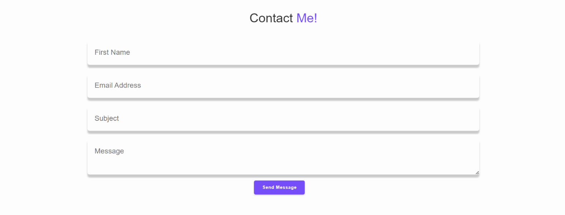

figure 2.2.1

**Description:**

The above displayed figure 2.2.1 is a contact page in the website. If the user wants to contact me, they can fill the form with their valid details.

HTML:

 <!-- Contact section design  -->

    <section class="contact" id="contact">

        <h2 class="heading">Contact <span>Me!</span></h2>

<form action="" class="contact__form" id="contact-form">

        <div class="contact__group">

           <div class="contact__box">

            <label for="name" class="contact__label"></label>

              <input type="text" name="user_name" class="contact__input" id="name" required placeholder="First Name">

           </div>

           <div class="contact__box">

            <label for="email" class="contact__label"></label>

              <input type="email" name="user_email" class="contact__input" id="email" required placeholder="Email Address">

           </div>

        </div>

        <div class="contact__box">

          <label for="subject" class="contact__label"></label>

           <input type="text" name="user_subject" class="contact__input" id="subject" required placeholder="Subject">

        </div>

       <div class="contact_box contact_area">

        <label for="message" class="contact__label"></label>

         <textarea name="user_message" id="message" class="contact__input" required placeholder="Message"></textarea>

       </div>

       <p class="contact__message" id="contact-message"></p>

        <button type="submit" class="btn">

           <i class="ri-send-plane-fill"></i>Send Message

        </button>

         </form>

    </section>

CSS FILE:

.contact h2 {

    margin-bottom: 3rem;

}

.contact__form {

    max-width: 140rem;

    margin: 1rem auto;

    text-align: center;

    margin-bottom: 3rem;

}

.contact__group {

    display: flex;

    justify-content: space-between;

    flex-wrap: wrap;

}

.contact form .contact__input, .contact__textarea {

    width: 140rem;

    padding: 2.5rem;

    font-size: 2.6rem;

    color: var(--text-color);

    background: var(--bg-color);

    border-radius: .8rem;

    margin: .7rem 0;

    box-shadow: 0 1rem .5rem var(--shadow-color);

}

.contact__input {

    width: 59%;

}

.contact__textarea {

    resize: none;

}

.contact btn {

    margin-top: 4rem;

    cursor: pointer;

}

**CHAPTER 3:**

**PAGES AND NAVIGATION:**

**3.1 Landing page:**

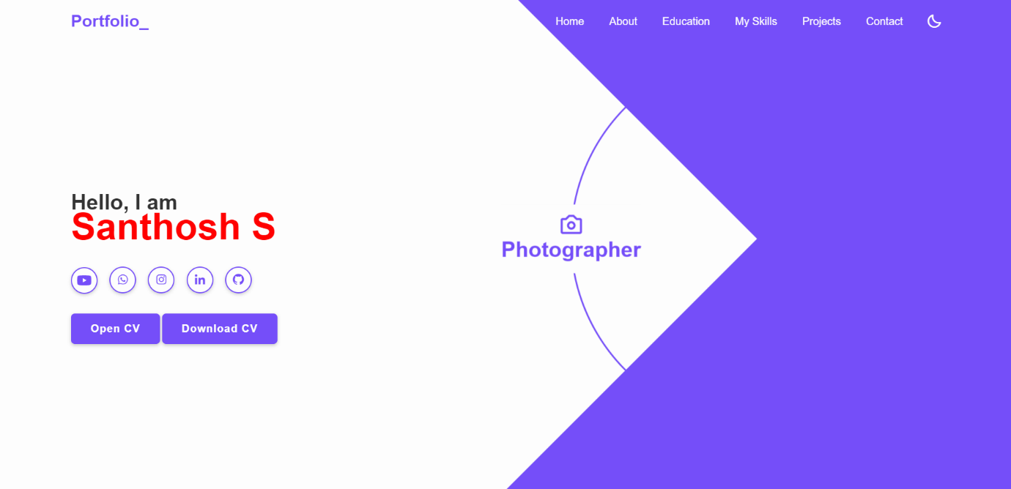

figures 3.1.1

**Description:**

The above figures 3.1.1 are the screenshot of Homepage in a desktop view. And this is a home screen of the portfolio which shows the landing page and Navigation bar. which shown as figures 3.1.1.

HTML FILE:

     <header class="header">

        <a href="#" class="logo">Portfolio_</a>

        <nav class="navbar">

            <a href="#home" class="active">Home</a>

            <a href="#about">About</a>

            <a href="#education">Education</a>

            <a href="#skills">My Skills</a>

            <a href="#project">Projects</a>

            <a href="#contact">Contact</a>

        </nav>

        <div class="bx bx-moon" id="darkmood-icon"></div>

<div class="bx bx-menu" id="menu-icon"></div>

</header>

    <!-- home section design -->

    <section class="home" id="home">

        <div class="home-content">

            <h3>Hello, I am</h3>

            <h1>Santhosh S</h1>

            <div class="social-media">

                <a href="https://youtu.be/6ibDQurRrY8?si=euZjItLDsOzntiSI"><i class='fab fa-youtube'></i></a>

                <a href="https://wa.me/qr/ICDBYVCXTWXRK1"><i class='bx bxl-whatsapp'></i></a>

                <a href="https://instagram.com/i_n_s_t_r_o_n_._m_.a_._d._d_.y?igshid=OGQ5ZDc2ODk2ZA=="><i class='bx bxl-instagram' ></i></a>

                <a href="https://www.linkedin.com/in/santhosh-s-832596250/"><i class='bx bxl-linkedin' ></i></a>

                <a href="https://github.com/SANTHOSHS-MCA23"><i class='bx bxl-github' ></i></a>

            </div>

            <a href="https://santhoshs-mca23.github.io/RESUMEA/" class="btn">Open CV</a>

            <a href="./resume/SANTHOSH MCA.pdf" class="btn">Download CV</a>

        </div>

        <div class="profession-container">

            <div class="profession-box">

                <div class="profession"  style="--i:0;">

                    <i class='bx bx-code'></i>

                    <h3>Web Developer</h3>

                </div>

                <div class="profession" style="--i:1;">

                    <i class='bx bx-camera' ></i>

                    <h3>Photographer</h3>

                </div>

                <div class="profession" style="--i:2;">

                    <i class='bx bx-palette' ></i>

                    <h3>Web Designer</h3>

                </div>

                <div class="profession" style="--i:3;">

                    <i class='bx bx-video-recording' ></i>

                    <h3>Videographer</h3>

                </div>

                <div class="circle"></div>

            </div>

            <div class="overlay">

            </div>

            </div>

    </section>

<!-- home section ends -->

CSS FILE:

* home */

header{

    position: fixed;

    top: 0;

    left: 0;

    width: 100%;

    padding: 2rem 7%;

    background: transparent;

    display: flex;

    align-items: center;

    z-index: 100;

    transition: .1s;

}

.header.sticky{

    background: var(--bg-color);

    box-shadow: 0 .1rem 1rem var(--shadow-color);

}

.logo{

    font-size: 2.5rem;

    color:var(--main-color);

    font-weight: 600;

    cursor:default;

    margin-right: auto;

}

.navbar a{

    position: relative;

    font-size: 1.6rem;

    color: var(--white-color);

    font-weight: 500;

    margin-right: 3.5rem;

}

.header.sticky .navbar a{

    color: var(--main-color);

}

.header.sticky .navbar a.active{

    color: var(--main-color);

}

.navbar a.active::before{

    content: '';

    position: absolute;

    left: 0;

    bottom: -6px;

    width: 100%;

    height: .2rem;

    background: var(--main-color);

}

.header.sticky .navbar a::before{

    background: var(--main-color);

    opacity: .7;

}

#darkmood-icon{

    font-size: 2.4rem;

    color: var(--white-color);

    cursor: pointer;

}

.header.sticky #darkmood-icon{

    color: var(--text-color);

    opacity: .9;

}

#menu-icon{

    font-size: 3.6rem;

    color: var(--text-color);

    display: none;

}

section{

    min-height:100vh;

    padding: 10rem 7% 2rem;

}

.home{

    display: flex;

    align-items: center;

}

.home .home-content{

    max-width: 44rem;

}

.home-content h3{

    font-size: 3.2rem;

    font-weight: 700;

    line-height: .3;

}

.home-content h1{

    font-size: 5.6rem;

    font-weight: 700;

    margin-bottom: .3rem;

    color: red;

}

.home-content p{

    font-size: 1.6rem;

}

.home-content .social-media a{

display: inline-flex;

    justify-content: center;

    align-items: center;

    width: 4rem;

    height: 4rem;

    background: transparent;

    border: .2rem solid var(--main-color);

    border-radius: 50%;

    box-shadow: 0 .2rem .5rem var(--shadow-color);

    font-size: 2rem;

    color: var(--main-color);

    margin: 2.5rem 1.5rem 3rem 0;

    transition: .5s ease;

}

.home-content .social-media a:hover{

    background-color: var(--main-color);

    color: var(--white-color);

}

.btn{

    display: inline-block;

    padding: 1.2rem 2.8rem;

    background: var(--main-color);

    border-radius: .6rem;

    box-shadow: 0 .2rem .5rem var(--shadow-color);

    font-size: 1.6rem;

    color: var(--white-color);

    letter-spacing: .1rem;

    font-weight: 600;

    border: .2rem solid transparent;

    transition: .5s ease;

}

.btn:hover{

    background: transparent;

    color: var(--main-color);

    border-color: var(--main-color);

}

.home .profession-container{

    position: absolute;

    top: 50%;

    right: 0;

    transform: translateY(-50%);

    width: 786px;

    height: 786px;

    overflow: hidden;

    pointer-events: none;

}

.home .profession-container .profession-box{

    position: absolute;

    top: 0;

    right: 0;

    width: 768px;

    height: 768px;

    border-radius: 50%;

    display: flex;

    justify-content: center;

    align-items: center;

    animation: professionRotate 8s ease-out infinite;

}

@keyframes professionRotate{

    0%,20%{

        transform: rotate(0deg)

    }

    25%,45%{

        transform: rotate(-90deg)

    }

    50%,70%{

        transform: rotate(-180deg)

    }

    75%,95%{

        transform: rotate(-270deg)

    }

    100%{

        transform: rotate(-360deg)

    }

}

.home .profession-box .profession{

    position: absolute;

    display: flex;

    left: 0;

    align-items: center;

    flex-direction: column;

    color: var(--main-color);

    transform: rotate(calc(360deg / 4 * var(--i)));

    transform-origin: 384px;

    background: var(--bg-color);

    padding: 13px 0;

}

.home .profession-box .profession:nth-child(1) i{

    margin-right: 15px;

}

.home .profession-box .profession:nth-child(2),

.home .profession-box .profession:nth-child(4) {

    padding-bottom: 20px;

}

.home .profession i{

    font-size: 3.8rem;

}

.home .profession h3{

    font-size: 3.2rem;

    line-height:1 ;

    font-weight: 600;

}

.home .profession-box .circle{

    width: 560px;

    height: 560px;

    border: 3px solid var(--main-color);

    border-radius: 50%;

}

.home .profession-container .overlay{

    position: absolute;

    top: 0;

    right: 0;

    width: 0;

    height: 0;

    border-top: 384px solid var(--main-color);

    border-right: 384px solid var(--main-color);

    border-bottom: 384px solid var(--main-color);

    border-left: 384px solid transparent;

}

.home-img img{

    position: absolute;

    bottom: 0;

    right: 0;

    width: 50%;

    top: 100px;

    pointer-events: none;

}

  /* header */

**3.2 PROJECT PAGE:**

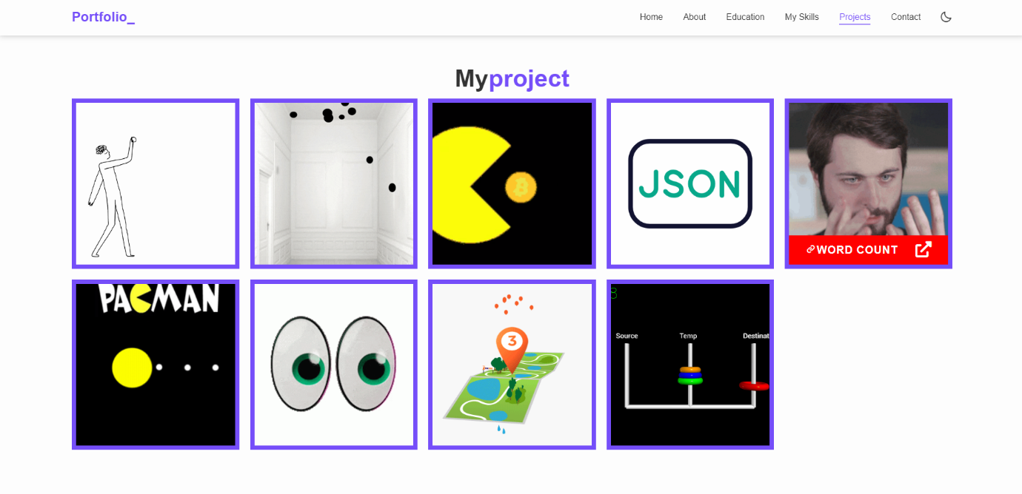

HTML FILE:

<section class="project" id="project">

    <h1 class="heading">My<span>project</span></h1>

    &nbsp;

    <div class="box-container">

      <div class="box">

        <div class="image">

          <img src="./images/giphy 1.gif" alt="" />

          <div class="content">

            <a href=" https://santhoshs-mca23.github.io/Week_1-CrossBall/"><h2><i class='bx bx-link' ></i>BALL MOVEMENT &nbsp;&nbsp;&nbsp;&nbsp;</h2></a>

            <a href="https://github.com/SANTHOSHS-MCA23/Week_1-CrossBall"><h3><i class="fas fa-external-link-alt"></i></h3></a>

          </div>

        </div>

      </div>

      <div class="box">

        <div class="image">

          <img src="images/giphy (1).gif" alt="" />

          <div class="content">

           <a href="https://santhoshs-mca23.github.io/Week_2_ball-creation/"> <h2><i class='bx bx-link' ></i>RANDOM BALL &nbsp;&nbsp;&nbsp;&nbsp;</h2></a>

           <a href="https://github.com/SANTHOSHS-MCA23/Week_2_ball-creation"><h3><i class="fas fa-external-link-alt"></i></h3></a>

          </div>

        </div>

      </div>

      <div class="box">

        <div class="image">

          <img src="images/pacman.gif" alt="" />

          <div class="content">

            <a href="https://santhoshs-mca23.github.io/Week_3-pacman/"><h2><i class='bx bx-link' ></i>PACMAN &nbsp;&nbsp;&nbsp;&nbsp;</h2></a>

            <a href="https://github.com/SANTHOSHS-MCA23/Week_3-pacman"><h3><i class="fas fa-external-link-alt"></i></h3></a>

          </div>

        </div>

      </div>

      <div class="box">

        <div class="image">

          <img src="images/portfolio-4.gif" alt="" />

          <div class="content">

            <a href="https://santhoshs-mca23.github.io/Week_4_Boston/"><h2><i class='bx bx-link' ></i>BOSTON &nbsp;&nbsp;&nbsp;&nbsp;</h2></a>

            <a href="https://github.com/SANTHOSHS-MCA23/Week_4_Boston"><h3><i class="fas fa-external-link-alt"></i></h3></a>

          </div>

        </div>

      </div>

      <div class="box">

        <div class="image">

          <img src="images/giphy.gif" alt="" />

          <div class="content">

           <a href="https://santhoshs-mca23.github.io/Week_5_Words-count/"> <h2><i class='bx bx-link' ></i>WORD COUNT &nbsp;&nbsp;&nbsp;&nbsp;</h2></a>

           <a href="https://github.com/SANTHOSHS-MCA23/Week_5_Words-count"><h3><i class="fas fa-external-link-alt"></i></h3></a>

          </div>

        </div>

      </div>

      <div class="box">

        <div class="image">

          <img src="images/pacman1.gif " alt="" />

          <div class="content">

           <a href="https://santhoshs-mca23.github.io/Week_6_Packman-game/"> <h2><i class='bx bx-link' ></i>PACMAN &nbsp;&nbsp;&nbsp;&nbsp;</h2></a>

           <a href="https://github.com/SANTHOSHS-MCA23/Week_6_Packman-game"><h3><i class="fas fa-external-link-alt"></i></h3></a>

          </div>

        </div>

      </div>

      <div class="box">

        <div class="image">

          <img src="images/eyes-moving.gif" alt="" />

          <div class="content">

            <a href="https://santhoshs-mca23.github.io/Week_7-Eye-rotation/"><h2><i class='bx bx-link' ></i>EYE MOVEMENT &nbsp;&nbsp;&nbsp;&nbsp;</h2></a>

            <a href="https://github.com/SANTHOSHS-MCA23/Week_7-Eye-rotation"><h3><i class="fas fa-external-link-alt"></i></h3></a>

          </div>

        </div>

      </div>

      <div class="box">

        <div class="image">

          <img src="images/portfolio-8.gif" alt="" />

          <div class="content">

            <a href="https://santhoshs-mca23.github.io/Week_8_Map-Animation/"><h2><i class='bx bx-link' >MAP &nbsp;&nbsp;&nbsp;&nbsp;</i></h2></a>

            <a href="https://github.com/SANTHOSHS-MCA23/Week_8_Map-Animation"><h3><i class="fas fa-external-link-alt"></i></h3></a>

          </div>

        </div>

      </div>

      <div class="box">

        <div class="image">

          <img src="images/portfolio-9.gif" alt="" />

          <div class="content">

            <a href="https://santhoshs-mca23.github.io/Week_9_Tower-Game/"><h2><i class='bx bx-link' ></i>TOWERS &nbsp;&nbsp;&nbsp;</h2></a>

            <a href="https://github.com/SANTHOSHS-MCA23/Week_9_Tower-Game"><h3><i class="fas fa-external-link-alt"></i></h3></a>

          </div>

        </div>

      </div>

    </div>

</section>

CSS:

.project .box-container .box .image {

    height: 30rem;

    overflow: hidden;

    position: relative;

  }

  .project .box-container .box .image img {

    width: 100%;

    height: 100%;

    object-fit: cover;

  }

  .project .box-container {

    display: grid;

    grid-template-columns: repeat(auto-fit, minmax(30rem, 1fr));

    gap: 2rem;

  }

  .project .box-container .box {

    background-color: var(--main-color);

    padding: 0.8rem;

    box-shadow: var(--box-shadow);

  }

  .project .box-container .box:hover .image img {

    transform: scale(1.2);

  }

  .project .box-container .box .image .content {

    position: absolute;

    left: 0;

    bottom: 0;

    right: 0;

    background-color: red;

    padding: 1rem;

    display: flex;

    align-items: center;

    justify-content: center;

    transform: translateY(100%);

  }

  .project .box-container .box .image .content h2 {

    font-size: 2rem;

    color: var(--white-color);

    letter-spacing: 0.1rem;

    text-transform: uppercase;

  }

  .project .content h3 {

    font-size: 3rem;

    color: var(--white-color);

    letter-spacing: 0.1rem;

    float: right;

    text-transform: uppercase;

  }

.project .box-container .box:hover .image .content {

    transform: translateY(0);

  }

**3.3 Navigation Bar:**



Desktop View

## figure-3.3.1

HTML FILE:

<!-- header section starts -->

    <header class="header">

        <a href="#" class="logo">Portfolio_</a>

        <nav class="navbar">

            <a href="#home" class="active">Home</a>

            <a href="#about">About</a>

            <a href="#education">Education</a>

            <a href="#skills">My Skills</a>

            <a href="#project">Projects</a>

            <a href="#contact">Contact</a>

        </nav>

  <!-- header section ends -->

CSS FILE:

header{

position: fixed;

top: 0;

    left: 0;

    width: 100%;

    padding: 2rem 7%;

    background: transparent;

    display: flex;

    align-items: center;

    z-index: 100;

    transition: .1s;

}

.header.sticky{

    background: var(--bg-color);

    box-shadow: 0 .1rem 1rem var(--shadow-color);

}

.logo{

    font-size: 2.5rem;

    color:var(--main-color);

    font-weight: 600;

    cursor:default;

    margin-right: auto;

}

.navbar a{

    position: relative;

    font-size: 1.6rem;

    color: var(--white-color);

    font-weight: 500;

    margin-right: 3.5rem;

}

.header.sticky .navbar a{

    color: var(--main-color);

}

.header.sticky .navbar a.active{

    color: var(--main-color);

}

.navbar a.active::before{

    content: '';

    position: absolute;

    left: 0;

    bottom: -6px;

    width: 100%;

    height: .2rem;

    background: var(--main-color);

}

.header.sticky .navbar a::before{

    background: var(--main-color);

    opacity: .7;

}

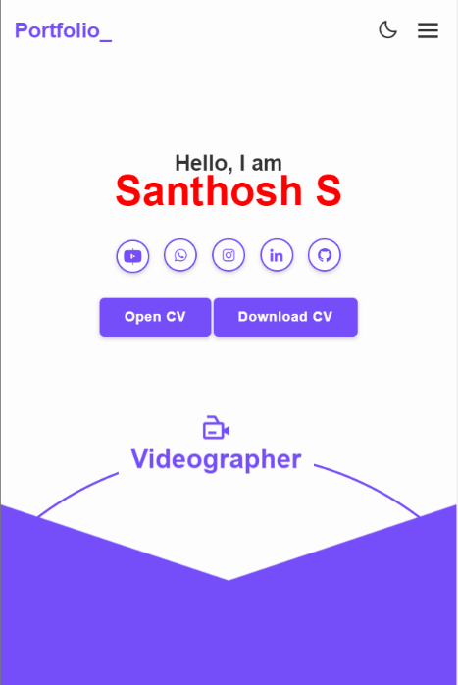

(Mobile view sample for one background image)

Figure 3.3.2

## Description:

The above figures 3.3.2 are the screenshot of Homepage in a Mobile view. And this is a home screen of the portfolio which shows the landing page with my resume and self-introduction video. which shown as figure 3.3.2

**3.3.3Navigation Bar**

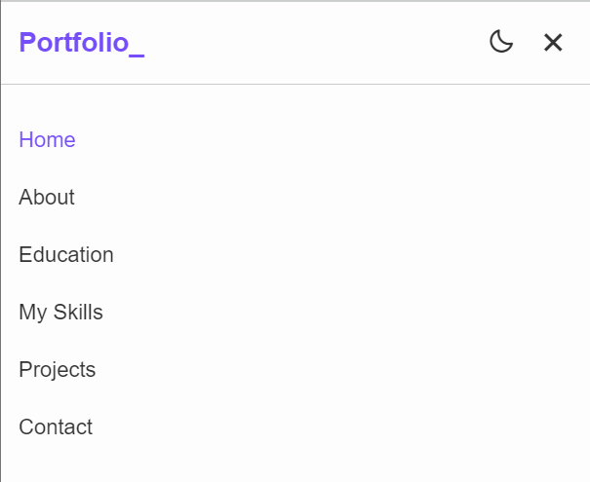

Figure -3.3.3 (mobile view)

## Description:

The figure-3.3.3 are the samples of navigation bar in both mobile View.This was a user-friendly method only, so the user can easily use the features.

## Features:

There are many styles are added. Whenever the user move lists to the navigation bar it will change the color to goldenrod. And also the navigation bar will be stable in the same position, even we switch to any other pages.

**Source Code:**

CSS:

@media (max-width:1200px){

    html{

        font-size: 55%;

    }

    .home .profession-container{

        height: 85.8rem;

    }

    .home .profession-container .profession-box{

        right: -12rem;

        height: 85.8rem;

    }

    .home .profession-container .overlay{

        right: -9rem;

    }

}

@media(max-width:1024px){

    .header{

        padding: 2rem 3%;

    }

    section{

        padding: 10rem 3% 2rem;

    }

    .home .profession-container .profession-box{

        right: -22rem;

    }

    .home .profession-container .overlay{

        right: -15rem;

    }

}

@media(max-width:991px){

    .navbar a:nth-child(0),

    .navbar a:nth-child(1){

        color: var(--main-color);

    }

    .navbar a.active::before{

        background: var(--main-color);

        opacity: .7;

    }

    .home .home-content{

        max-width: 50rem;

    }

    .home .profession-container .profession-box{

        right: -45rem;

    }

    .home .profession-container .overlay{

        right: -39.5rem;

    }

    .home-img img{

        display: none;

    }

    .skills .project{

        padding-bottom: 7rem;

    }

    .contact{

        min-width: auto;

    }

    .footer{

        padding: 2rem 3%;

    }

}

@media(max-width:768px){

    #menu-icon{

        display: block;

    }

    #darkmood-icon{

        position: absolute;

        right: 7rem;

        font-size: 2.6rem;

        color: var(--text-color);

        margin-bottom: .1rem;

    }

    .navbar{

        position: absolute;

        top: 100%;

        left: 0;

        width: 100%;

        padding: 1rem 3%;

        background: var(--bg-color);

        border-top: .1rem solid rgba(0,0,0, .2);

        box-shadow: 0 .5rem 1rem solid rgba(0,0,0, .1);

        display: none;

    }

    .navbar.active{

        display: block;

    }

    .navbar a{

        display: block;

        font-size: 2rem;

        margin: 3rem 0;

        color: var(--text-color);

    }

    .navbar a:nth-child(1),

    .navbar a:nth-child(2){

        color: var(--text-color);

    }

    .navbar a.active{

        color: var(--main-color);

    }

    .navbar a::before{

        display: none;

    }

    .home{

        padding: 0 3% 23rem;

        justify-content: center;

        text-align: center;

    }

    .home-content h3{

        font-size: 2.6rem;

    }

    .home-content h1{

        font-size: 5rem;

    }

    .home-content .social-media a{

        margin: 2.5rem .75rem 3rem;

    }

    .home .profession-container{

        left: 0;

        width: 100%;

height: 100%;

    }

    .home .profession-container .profession-box{

        position: fixed;

        top: 60%;

        left: 0;

        border-radius: 0;

        width: 100%;

    }

    .home .profession-box .profession{

        padding: 0 13px;

        left: auto;

        transform-origin: 0;

    }

    .home .profession-box .profession:nth-child(1){

        transform: rotate(-90deg) translate(-120px,-210px);

    }

    .home .profession-box .profession:nth-child(1) i{

       margin-right: 0;

    }

    .home .profession-box .profession:nth-child(2){

        transform: rotate(0deg) translate(0,-335px);

    }

    .home .profession-box .profession:nth-child(3){

        transform: rotate(90deg) translate(-115px,-450px);

    }

    .home .profession-box .profession:nth-child(4){

        transform: rotate(180deg) translate(-220px,-335px);

    }

    .home .profession-box .circle{

        position: fixed;

        width: 670px;

        height: 670px;

        z-index: -1;

    }

    .home .profession-container .overlay{

        position: fixed;

        top: 70rem;

        left: 50%;

        right: 0;

        transform: rotate(90deg) translate(-50%, 50%) scaleY(3);

        border-width: 23.9rem;

    }

    .about{

        flex-direction: column-reverse;

        text-align: center;

    }

    .about-content h2{

        text-align: center;

    }

    .about-img img{

        width: 70vw;

        margin-top: -2rem;

    }

    .skills h2,

    .project h2{

        margin-bottom: 6rem;

    }

    .project .project-container{

        grid-template-columns: repeat(2, 1fr);

    }

}

@media(max-width:617px){

    .project .skills-container{

        grid-template-columns: 1fr;

    }

}

@media(max-width:450px){

    html{

        font-size: 50%;

    }

    #darkmood-icon{

        right: 6rem;

    }

    .home{

        padding: 0 3% 30rem;

    }

    .home .profession-box .profession:nth-child(1){

        transform: rotate(-90deg) translate(-110px,-220px);

    }

    .home .profession-box .profession:nth-child(2){

        transform: rotate(0deg) translate(5px,-335px);

    }

    .home .profession-box .profession:nth-child(3){

        transform: rotate(90deg) translate(-105px,-440px);

    }

    .home .profession-box .profession:nth-child(4){

        transform: rotate(180deg) translate(-210px,-335px);

    }

    .contact form .input-box input{

        width: 100%;

    }

}

@media(max-width:365px){

    .about-img img{

        width: 90vw;

    }

    .footer p{

        flex-direction: column-reverse;

    }

    .footer p{

        text-align: center;

        margin-top: 2rem;

    }

}

**3.4.Skills:**

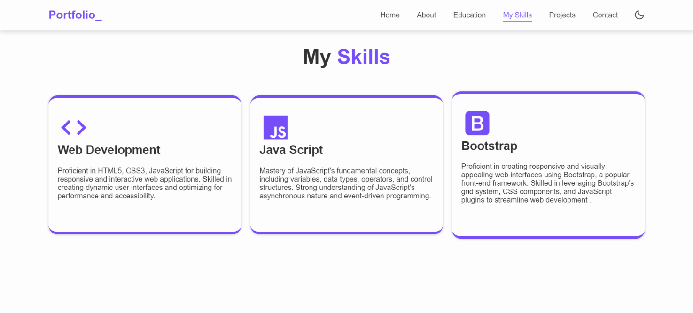

## Description:

The above figures are skill page, which contain a subdivision named PERSONAL SKILLS. Basically, it is an animation, when the user load the page it will load or fill the color in the bar from 0th position.

**Source Code:**

HTML:

 <!-- Skill Start -->

    <section class="skills" id="skills">

        <h2 class="heading">My <span>Skills</span></h2>

    <div class="skills-container">

        <div class="skills-box">

        <i class='bx bx-code'></i>

        <h3>Web Development</h3> <br>

        <p>Proficient in HTML5, CSS3, JavaScript for building responsive and interactive web applications.

           Skilled in creating dynamic user interfaces and optimizing for performance and accessibility. </p>

    </div>

        <div class="skills-box">

          <i class='bx bxl-javascript'></i>

        <h3>Java Script</h3> <br>

        <p>Mastery of JavaScript's fundamental concepts, including variables, data types, operators, and control structures.

          Strong understanding of JavaScript's asynchronous nature and event-driven programming. </p>

    </div>

        <div class="skills-box">

          <i class='bx bxl-bootstrap'></i>

        <h3>Bootstrap</h3> <br>

        <p>Proficient in creating responsive and visually appealing web interfaces using Bootstrap, a popular front-end framework.

           Skilled in leveraging Bootstrap's grid system, CSS components, and JavaScript plugins to streamline web development . </p>

    </div>

</div>

</section>

    <!-- Skill End -->

CSS:

.skills{

    min-height: auto;

    padding-bottom: 7rem;

}

.skills h2{

    margin-bottom: 5rem;

}

.skills .skills-container{

    display: flex;

    justify-content: center;

    align-items: center;

    flex-wrap: wrap;

    gap: 2rem;

}

.skills-container .skills-box{

    flex: 1 1 30rem;

    background: var(--bg-color);

    padding: 3rem 2rem 4rem;

    border-radius: 2rem;

    box-shadow: 0 .1rem .5rem var(--shadow-color);

    border-top: .6rem solid var(--main-color);

    border-bottom: .6rem solid var(--main-color);

    transition: .1s ease;

}

.skills-container .skills-box:hover{

    box-shadow: 0 .1rem 2rem var(--shadow-color);

    transform: scale(1.08);

}

.skills-box i{

    font-size: 7rem;

    color: var(--main-color);

}

.skills-box h3{

    font-size: 2.6rem;

    transition: .5s ease;

}

.skills-box:hover h3{

    color: var(--main-color);

}

.skills-box p{

    font-size: 1.6rem;

    margin: 1rem 0 3rem;

}

## CHAPTER 4:

**STYLES LINK:**

**4.1 styles(font color images):**

*{

    margin: 0;

    padding: 0;

    box-sizing: border-box;

    text-decoration: none;

    border: none;

    outline: none;

    scroll-behavior: smooth;

    font-family:'Poppins',sans-serif;

}

:root{

    --bg-color:#fdfdfd;

    --text-color:#333;

    --main-color:#754ef9;

    --white-color:#fdfdfd;

    --shadow-color:rgba(0,0,0, .2);

}

.dark-mode{

    --bg-color:#0b061f;

    --text-color:#fdfdfd;

    --shadow-color:rgba(0,0,0, .7);

}

html{

    font-size: 62.5%;

    overflow-x: hidden;

}

body{

    background-color: var(--bg-color);

    color: var(--text-color);

}

**4.2 styles links:**

 <!-- BOX ICONS -->

    <link href='https://unpkg.com/boxicons@2.1.4/css/boxicons.min.css' rel='stylesheet'>

    <!-- ICON  -->

    <link rel="stylesheet" href="https://cdnjs.cloudflare.com/ajax/libs/font-awesome/6.4.0/css/all.min.css">

    <link rel="stylesheet" href="https://cdnjs.cloudflare.com/ajax/libs/font-awesome/6.0.0-beta3/css/all.min.css">

    <link rel="stylesheet" href="./styles.css">

**CHAPTER 5:**

**Website include the following Information**

5.1 project links to GitHub:

# **PROJECT -1**

**Title:** SIMULATION BALL MOVEMENT

Link: **<https://santhoshs-mca23.github.io/Week_1-CrossBall/>**

* **Project Description:**

This HTML page displays a continuous bouncing red ball animation within a rectangular area, controlled by JavaScript using the setInterval function with a 500-millisecond interval.

# **PROJECT -2**

**Title:** GRAPHIC ANIMATION OF THE RANDOM WALK

Link: [**https://santhoshs-mca23.github.io/Week_2_ball-creation/**](https://santhoshs-mca23.github.io/Week_2_ball-creation/)

* **Project Description:**

Elevate the animation by enabling user input for modifying the ball's movement, incorporating elements like keyboard and mouse controls, as well as introducing obstacles or targets to enhance interactivity.

# 

# **PROJECT -3**

**Title:** PACMAN MOVEMENT

Link: **<https://santhoshs-mca23.github.io/Week_3-pacman/>**

* **Project Description:**

This HTML page features a Pac-Man animation moving horizontally within a container, controlled by JavaScript for direction, mouth animation, and boundary reversal, with a continuous animation loop triggered by setInterval every 100 milliseconds.

## PROJECT-4

**Title**: BOSTON CITY DATA

Link: [**https://santhoshs-mca23.github.io/Week_4_Boston/**](https://santhoshs-mca23.github.io/Week_4_Boston/)

* **Project Description:**

This JavaScript program retrieves and displays information about the top five earning employees in Boston, providing key details for each employee.

## PROJECT-5

**Title**: WORD COUNT

Link: [**https://santhoshs-mca23.github.io/Week_5_Words-count/**](https://santhoshs-mca23.github.io/Week_5_Words-count/)

* **Project Description:**

This HTML document displays the top 3 most frequently occurring words from a provided paragraph after removing punctuation and converting all text to lowercase.

# **PROJECT -6**

**Title:** RANDOM PACMAN

Link**: https://santhoshs-mca23.github.io/Week_6_Packman-game/**

* **Project Description:**

The HTML document creates a basic Pac-Man game with randomly generated Pac-Man characters that bounce off the container's boundaries and change mouth states while moving.

## PROJECT -7

**Title**: EYE-BALL MOVING

Link :**https://santhoshs-mca23.github.io/Week_7-Eye-rotation/**

* **Project Description:**

This HTML document creates a simple interactive face with moving eyes that follow the user's mouse cursor. The face consists of a yellow circle with two eyes, and the eyes' black pupils follow the mouse movement.

## PROJECT-8

**Title**: ROUTE MAP

Link: [**https://santhoshs-mca23.github.io/Week_8_Map-Animation/**](https://santhoshs-mca23.github.io/Week_8_Map-Animation/)

**Project Description:**

This HTML document displays a map using Mapbox and a button to animate a marker's movement along predefined bus stops between Gandhipuram and Sulur.

## PROJECT-9

**Title**: TOWERS OF HANOI

Link: **https://santhoshs-mca23.github.io/Week_9_Tower-Game/**

* **Project Description:**

The Tower of Hanoi is a classic puzzle where the objective is to move a stack of disks from one peg to

another .

**CHAPTER 6:**

**Bootsrap**

6.1 Uses of Bootstrap:

<!-- BOOTSTRAP  -->

    <link href="https://cdn.jsdelivr.net/npm/bootstrap@5.2.3/dist/css/bootstrap.min.css" rel="stylesheet">

    <link href="https://getbootstrap.com/docs/5.2/assets/css/docs.css" rel="stylesheet">

    <script src="https://cdn.jsdelivr.net/npm/bootstrap@5.2.3/dist/js/bootstrap.bundle.min.js"></script>

**Description:**

I have used bootstrap in this website. Which was a built in CSS file, so we can use it to reduce our time and also it carries a (N) number of designs. So, I had linked them to the code in HTML.

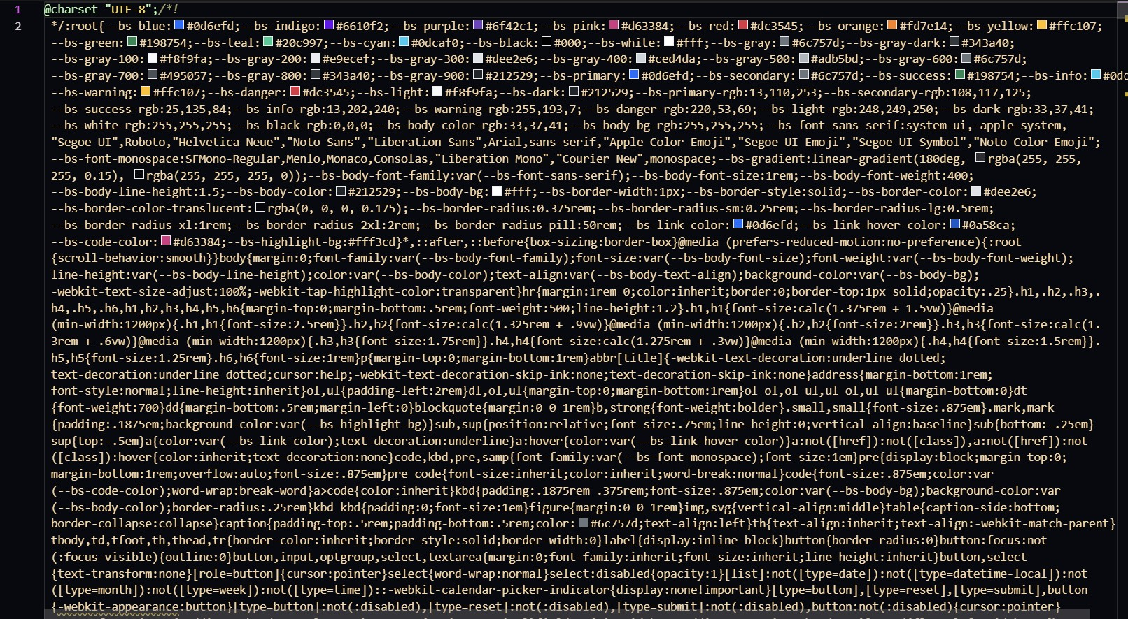

9

## CHAPTER 7:

## Project README

**PROJECT 1:** BALL MOVEMENT

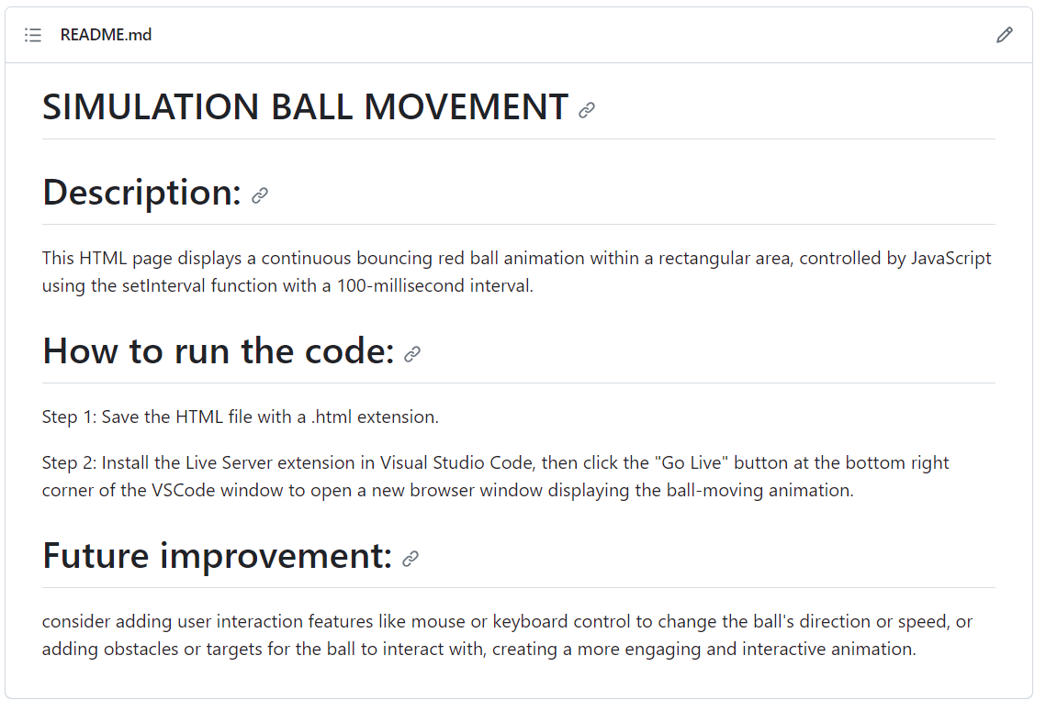

**PROJECT 2:** BOUNCING BALL

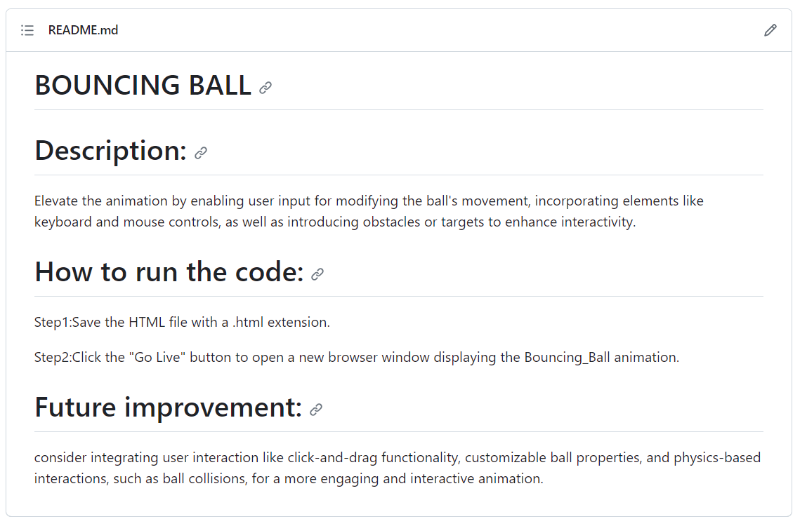

**PROJECT 3:** PACMAN

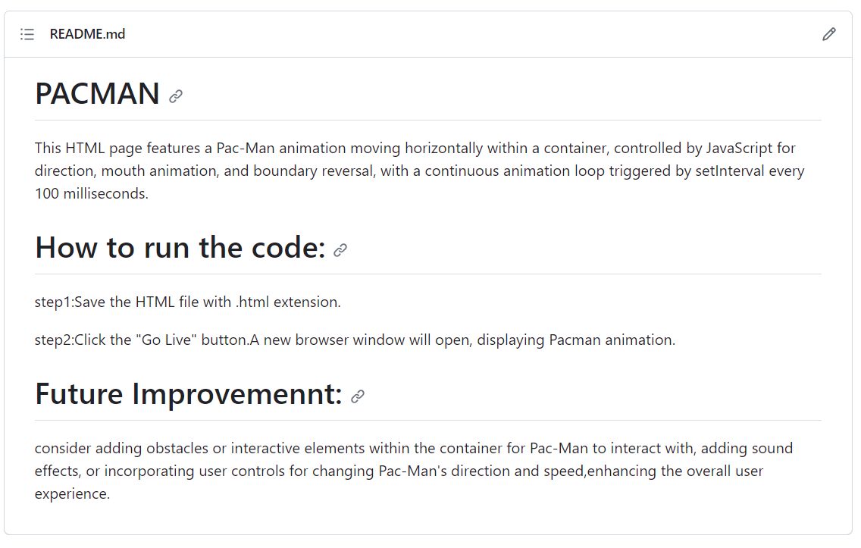

**PROJECT 4:** BOSTON

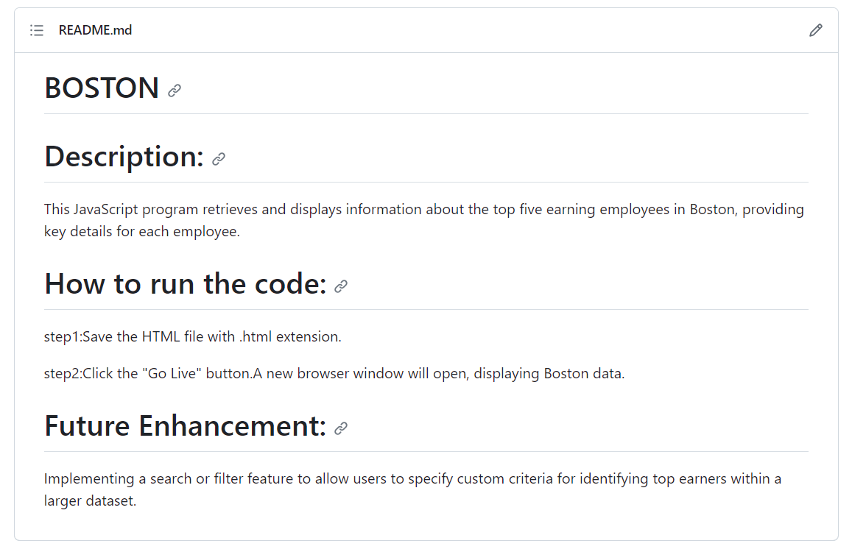

**PROJECT 5:** WORD COUNT

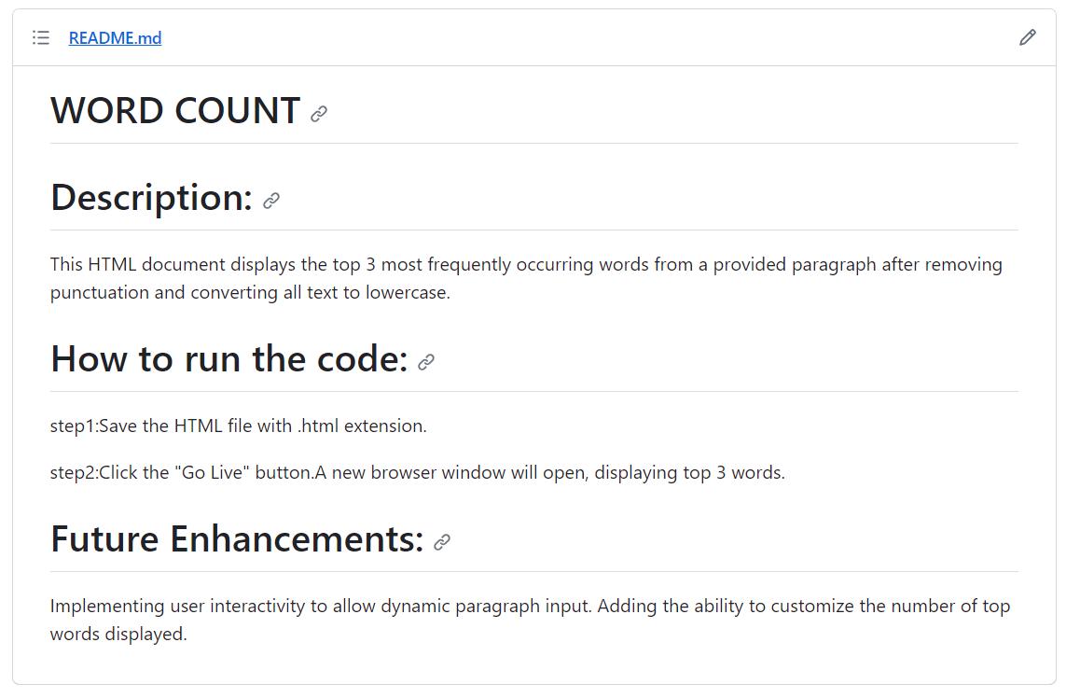

**PROJECT 6:** RANDOM PACMAN

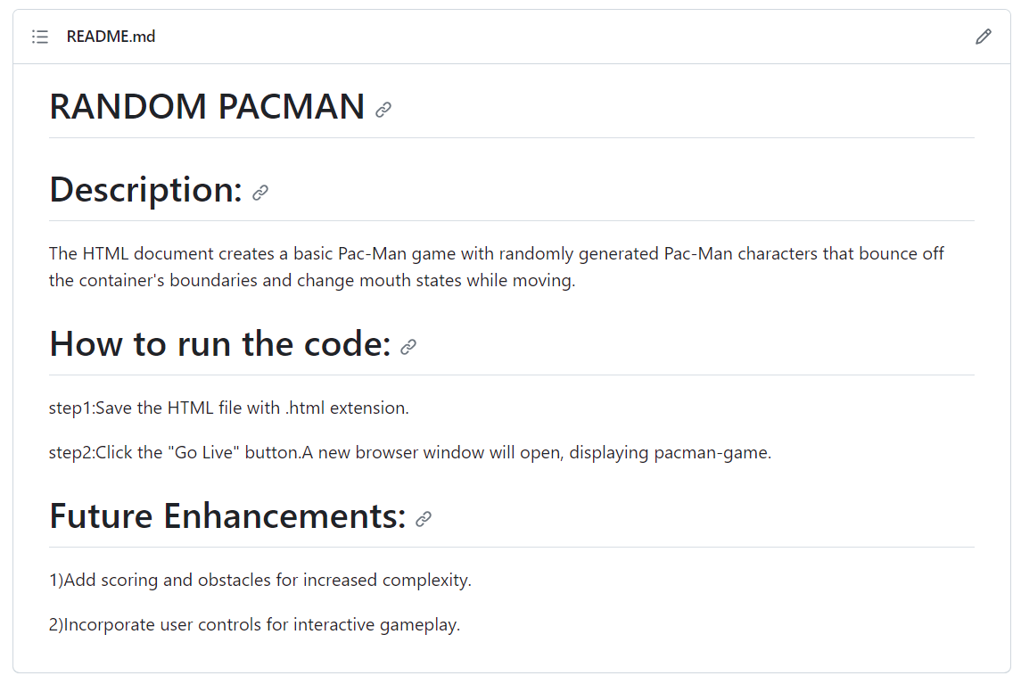

**PROJECT 7:** EYE MOVEMENT

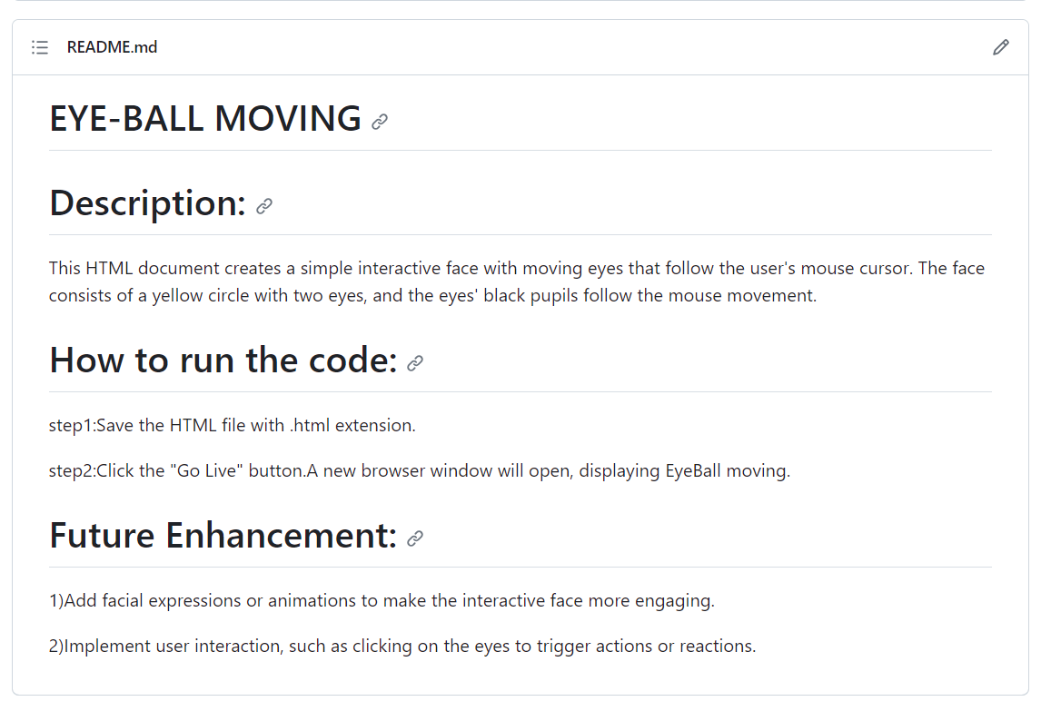

**PROJECT 8:** ROUTE MAP

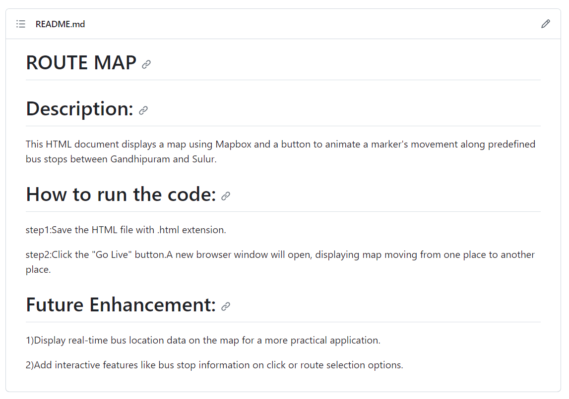

**PROJECT 9:** TOWER OF HANOI

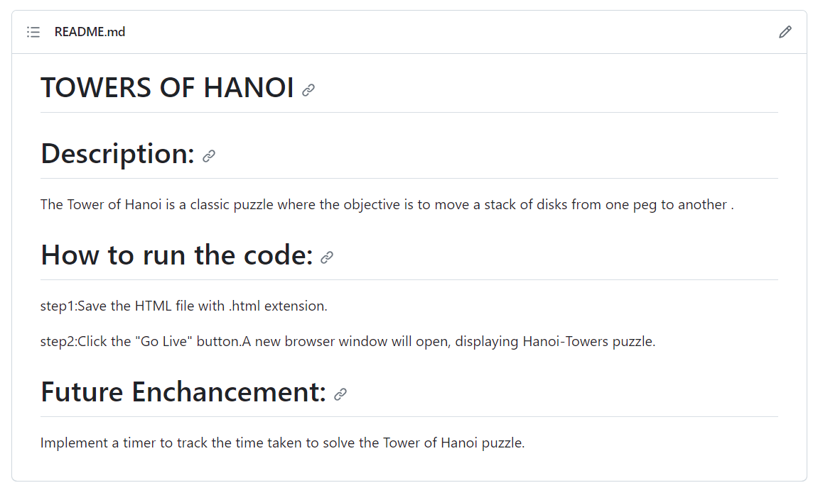

**Description:**

The above figures are the screenshot of project README files (Description, steps to run, future improvement) in a desktop view.

**CHAPTER 8:**

**File Structure**

8.1 GitHub File Structure

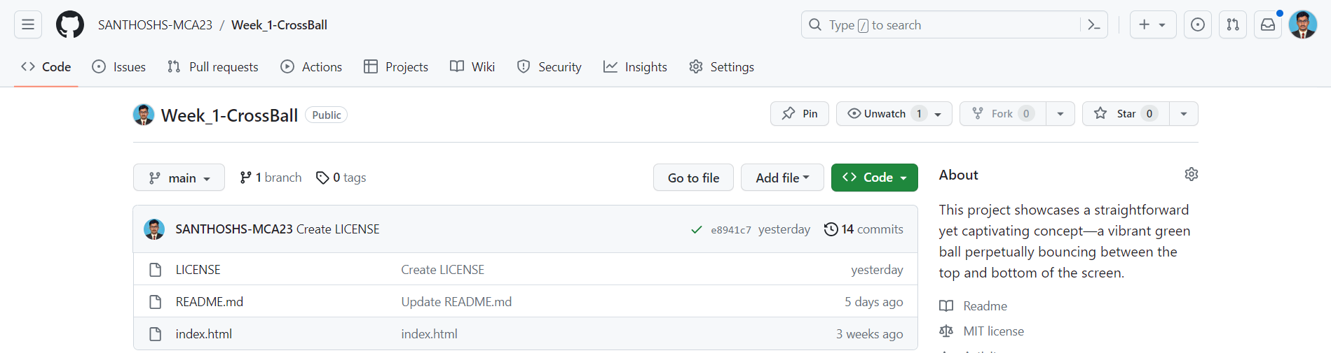

Figure 8.1.1

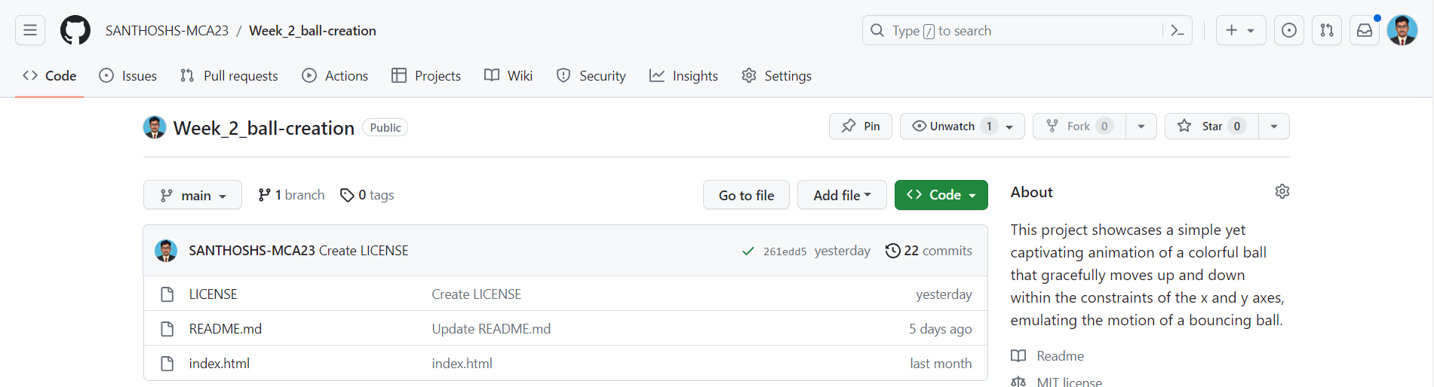

Figure 8.1.2

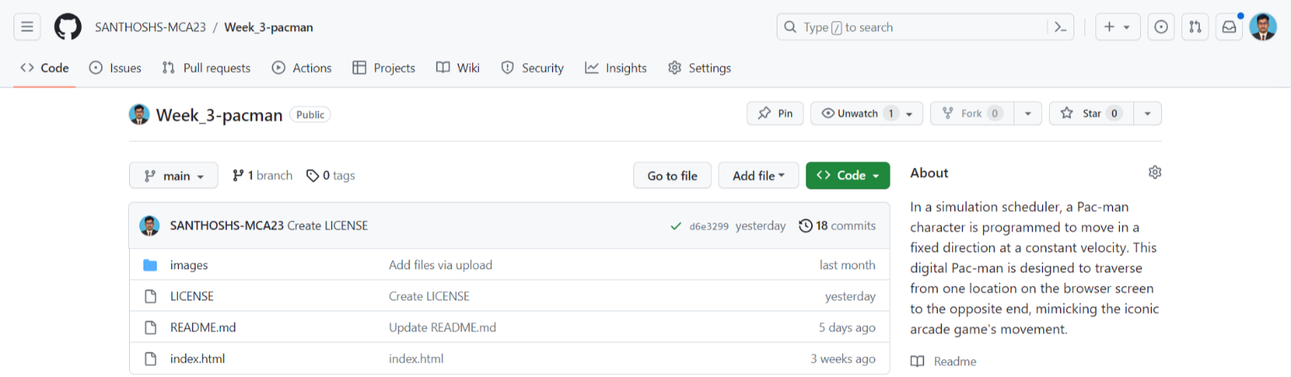

Figure 8.1.3

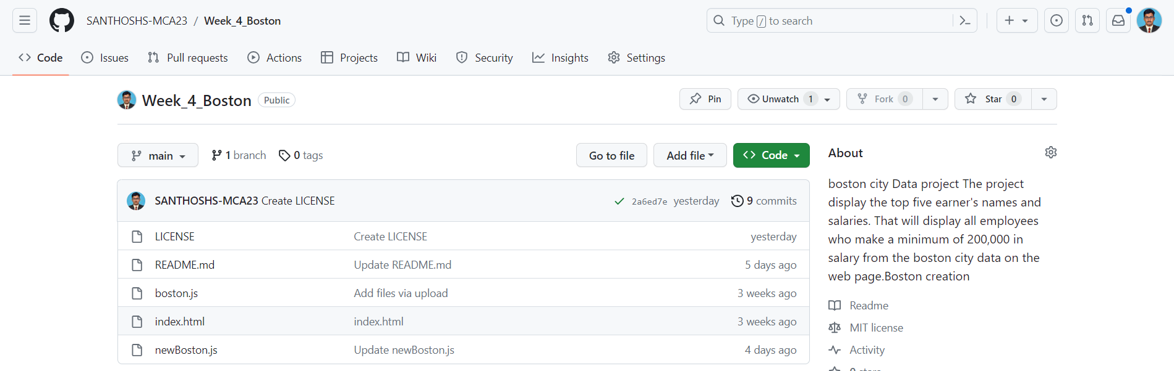

Figure 8.1.4

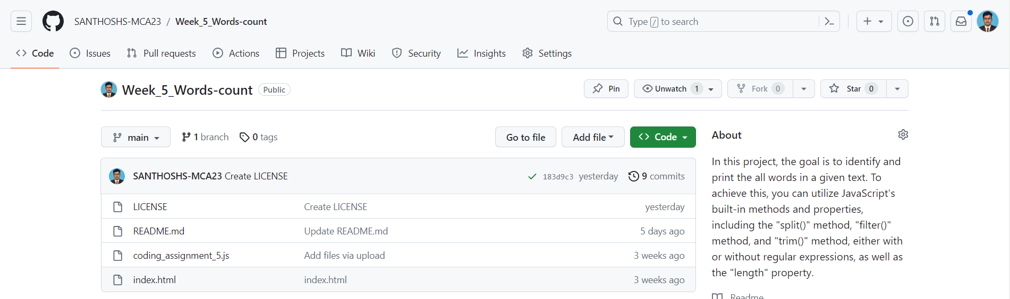

Figure 8.1.5

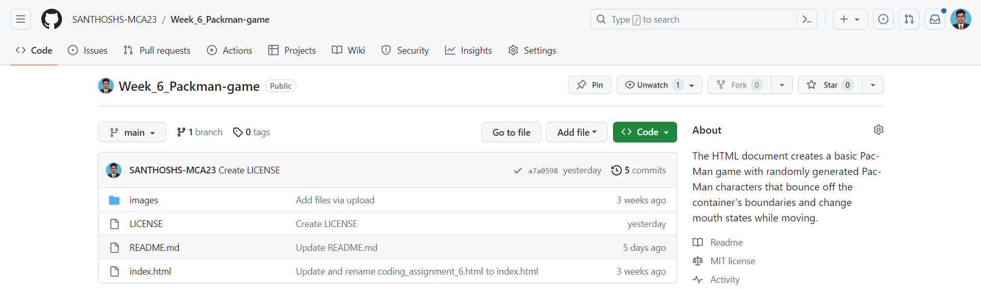

Figure 8.1.6

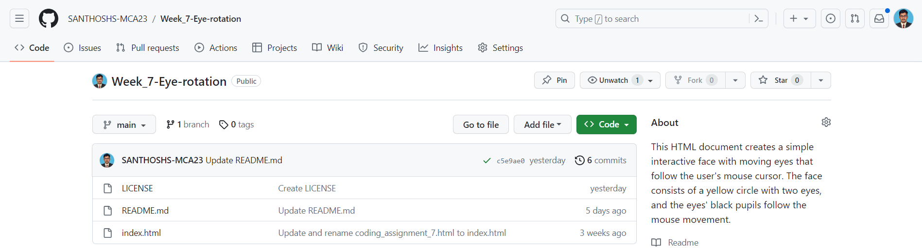

Figure 8.1.7

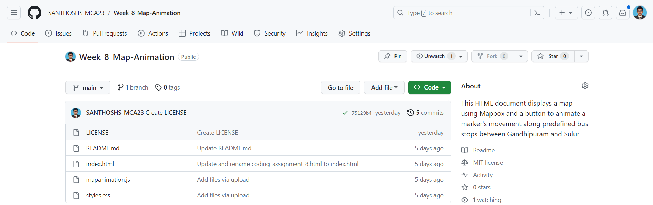

Figure 8.1.8

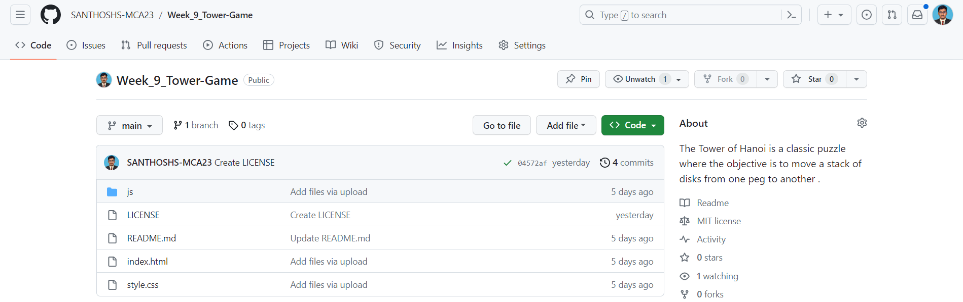

Figure 8.1.9

## Description:

This above Figures 8.1.1, 8.1.2, 8.1.3, 8.1.4, 8.1.5, 8.1.6, 8.1.7, 8.1.8, 8.1.9 shows GitHub File Structure in desktop view.